**PROJECT REPORT**

**Submitted by:**

**Gurseerat (2018CSB1093)**

**Sweety (2018CSB1122)**

**Submitted to:**

**Dr. Neeraj Goel**

**Fast Multipliers:** Wallace Multiplier and Dadda Multiplier

**Wallace Multiplier**

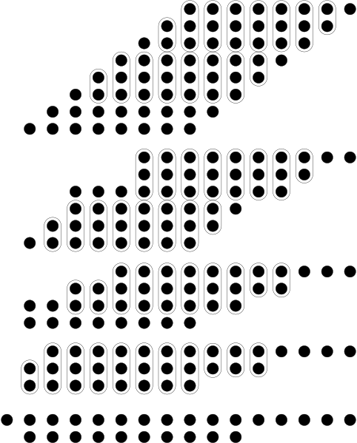

**The benefit of the Wallace tree is that there are only O ( log ⁡ n ) reduction layers, and each layer has O ( 1 ) propagation delay. As making the partial products is O ( 1 ) and the final addition is O ( log ⁡ n ) the multiplication is only O ( log ⁡ n ) , not much slower than addition (however, much more expensive in the gate count)**

**Output:**

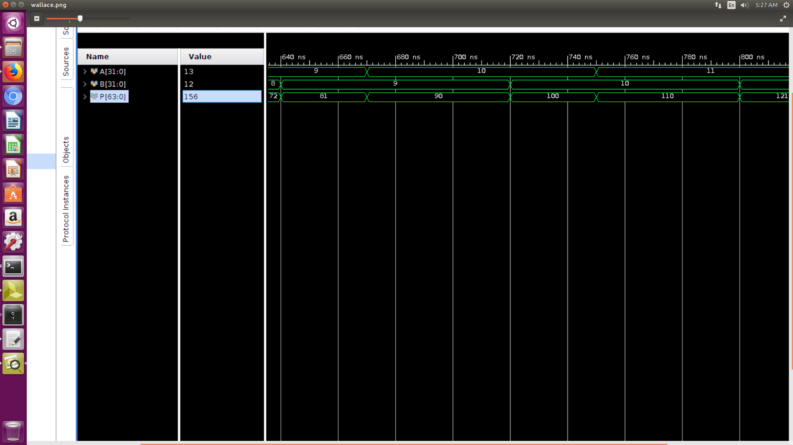

Output of Wallace tree multiplier

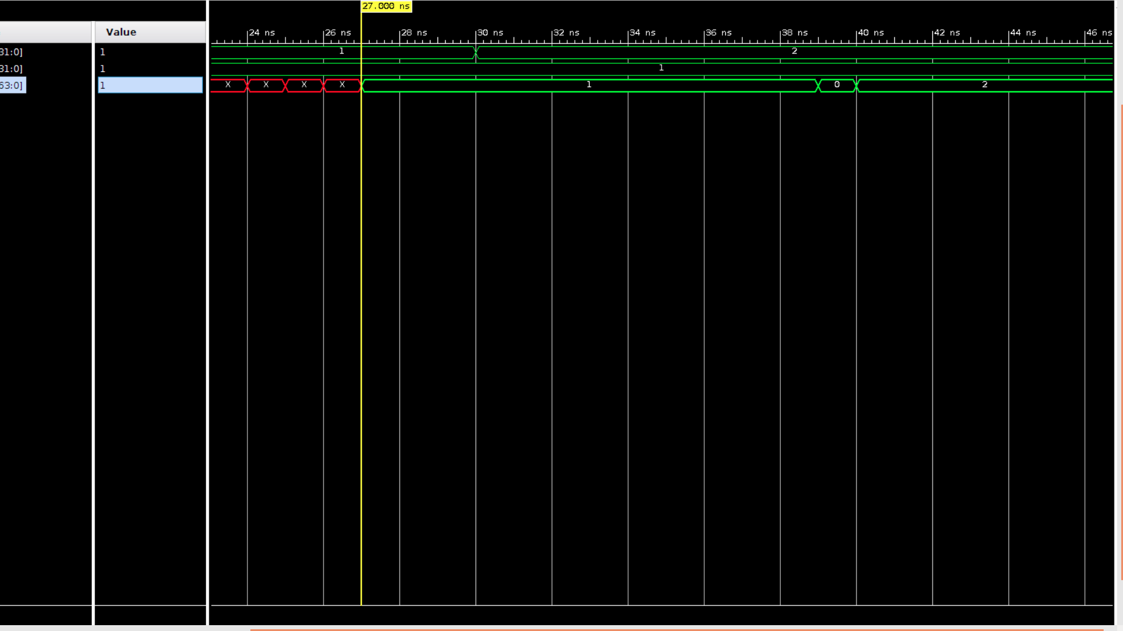

The Delay of 27,000ns is observed in Wallace tree multiplier due to the Gate delays in the multiplier and full and half adders.

**Dadda Multiplier**



**The Daddu multiplier is a hardware multiplier design .It is similar to the wallace multiplier, but it is slightly faster (for all operand sizes) and requires fewer gates (for all but the smallest operand sizes).**

**Unlike Wallace multipliers that reduce as much as possible on each layer, Dadda multipliers attempt to minimize the number of gates used, as well as input/output delay. Because of this, Dadda multipliers have a less expensive reduction phase, but the final numbers may be a few bits longer, thus requiring slightly bigger adders.**

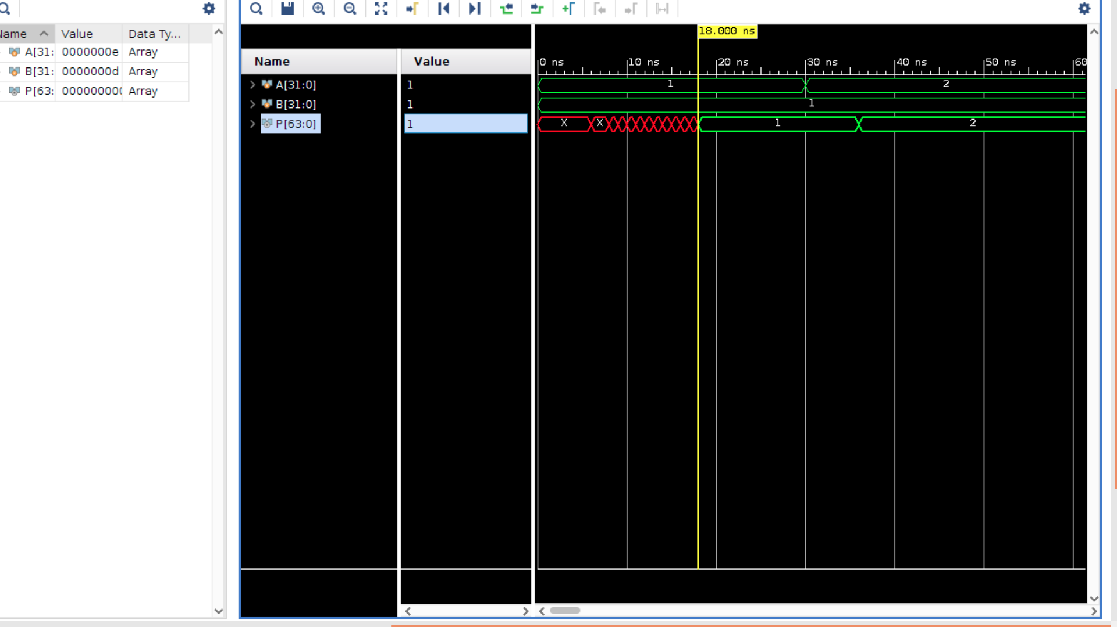

The output observed is as shown in the pictures. A delay of 18,000 ns is observed because of the gate delays in the dadda multiplier and the half and full adders.

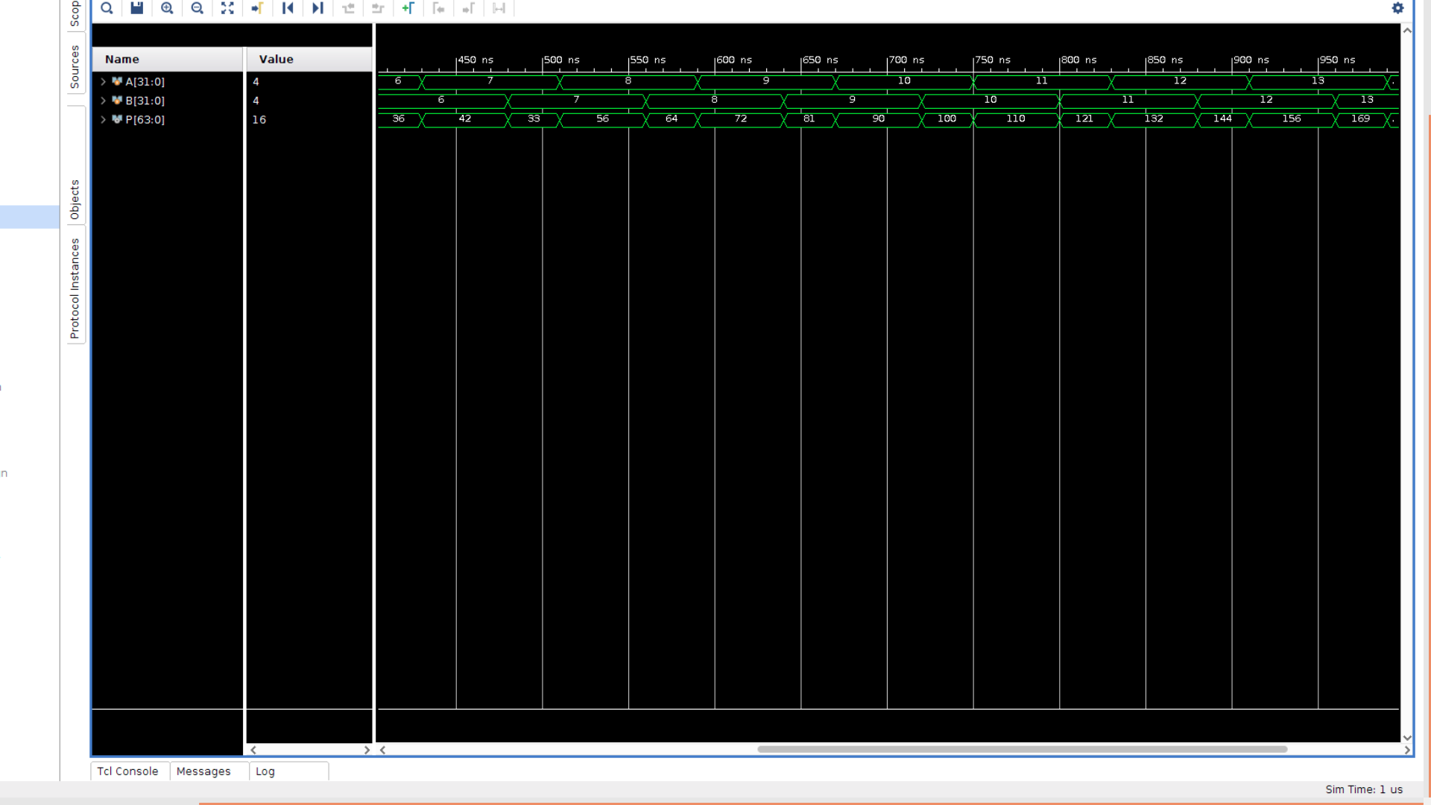

**Classical multiplier:**

**The 32 bit input is broken into 4 eight bit inputs which are further divided into 4 two bit multipliers and their partial products are combined at the end to get the final answer by their addition.**

**Comparison:**

For the same input (Example 2 and 1), the classical multiplier takes time longer than the Dadda and Wallace Multiplier and thus fast multipliers are prefered.

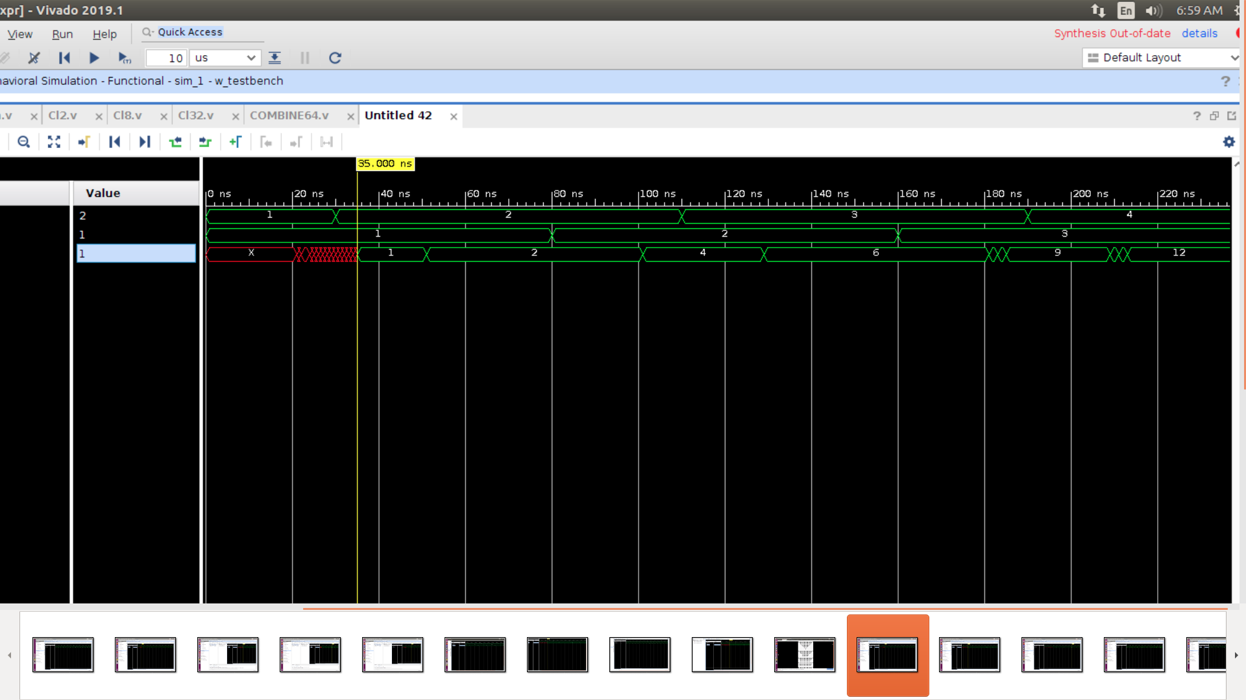

**The delay in classical multiplier is coming out as 35,000ns which is much greater than the Dadda and Wallace multipliers.**